ADDB6311 PRACTICAL ASSIGNMENT.1.

ST10070599

Tebogo Sebola

2024

|  |  |
| --- | --- |
| DECLARATION | SIGN |
| I have read the assessment rules provided in this declaration. |  |
| This assessment is my own work. |  |
| I have not copied any other student’s work in this assessment. |  |
| I have not uploaded the assessment question to any website or App offering assessment assistance. |  |
| I have not downloaded my assessment response from a website. |  |
| I have not used any AI tool without reviewing, re-writing, and re-working this information, and referencing any AI tools in my work. |  |
| I have not shared this assessment with any other student. |  |
| I have not presented the work of published sources as my own work. |  |
| I have correctly cited all my sources of information. |  |
| My referencing is technically correct, consistent, and congruent. |  |
| I have acted in an academically honest way in this assessment. |  |

QUESTION 1.

(LucidCharts)

QUESTION 2.

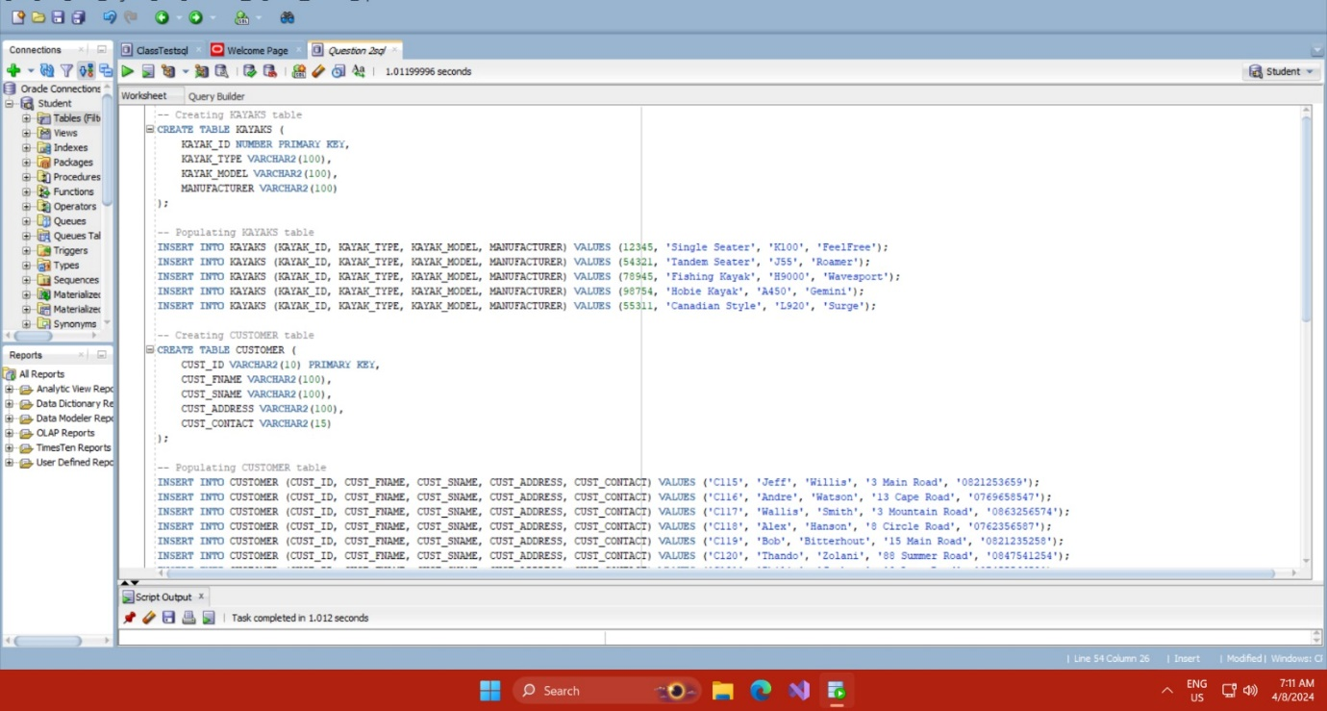

(IIE, 2024)

QUESTION 3.

(IIE, 2024)

QUESTION 4.

(IIE, 2024)

QUESTION 5.

(IIE, 2024)

QUESTION.6

(IIE, 2024)

QUESTION.7

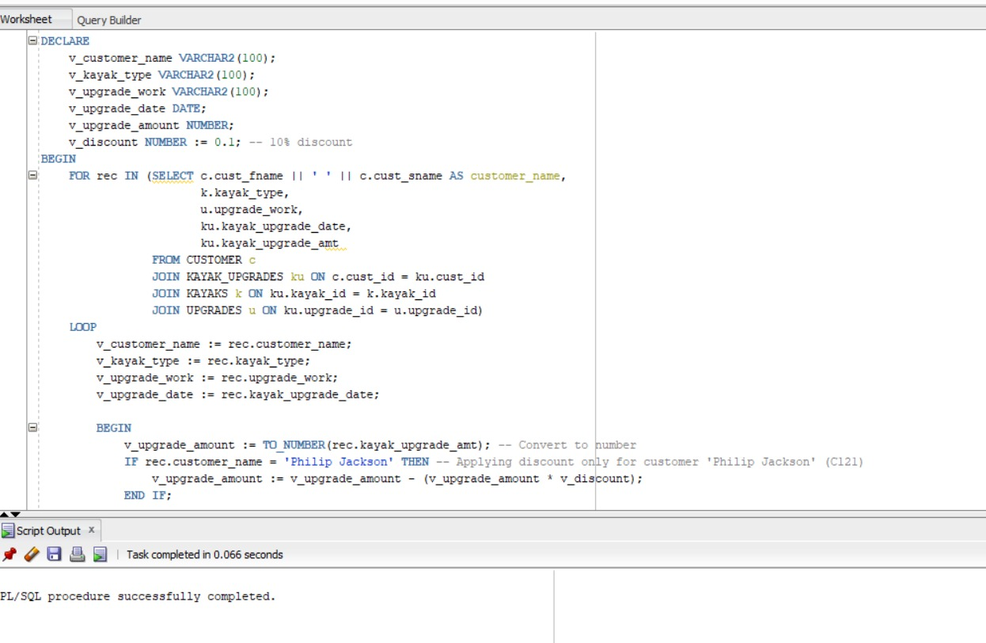

(IIE, 2024)

QUESTION.8

(IIE, 2024)

# References

IIE, T., 2024. Oracle. *ADVANCED DATABASES: MODULE MANUAL,* 1st(24), pp. 18-120.